FEFL01 – Output in jsbin.com



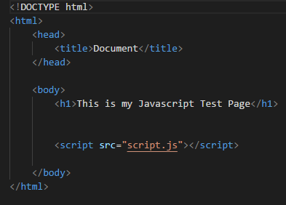

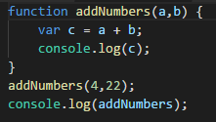

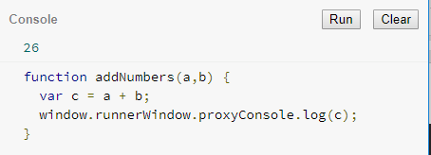

L01HandsOn

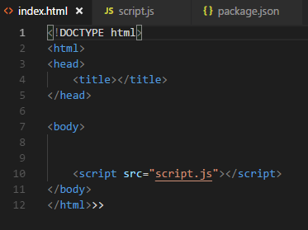

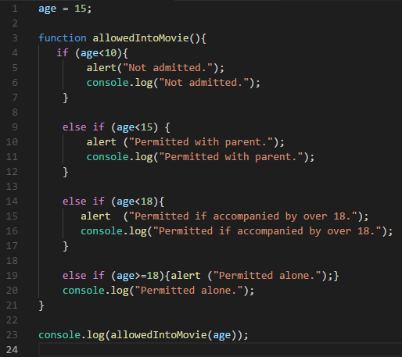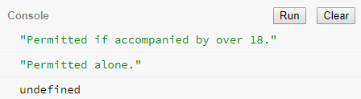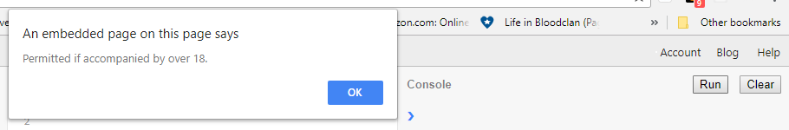

L02HandsOn

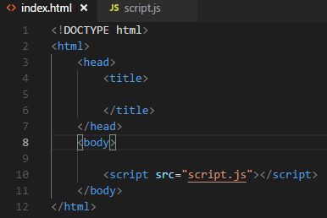

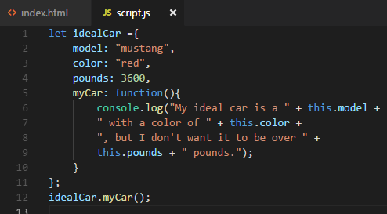

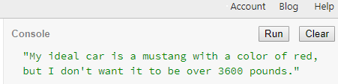

FEFL04

{//Define class

class aClass{

constructor(name,age){

this.name=name;

this.age=age;

}

// Method for class

sayName(){

alert(this.name);

}

//Method for class

sayAge(){

alert (this.age);

}

}

{//Instantiating the aClass with the 'new' keyword

const myInstance = new aClass("Andrew", 30);

myInstance.sayName();

}

{class Vehicle{

constructor(make, model, year){

this.make;

this.model;

this.year;

}

}

let myCar=new Vehicle("Nissan", "Rogue", 2017);

console.log(myCar());

//console.log does not work as lesson says it will. Returns [Object, Object]

}

{class Person {

constructor(firstName, lastName) {

this.firstName=firstName;

this.lastName=lastName;

}

run(){

console.log(this.firstName + " " + this.lastName + " is running.");

}

walk() {

console.log(this.firstName + " " + this.lastName + " is walking.");

}

greeting() {

console.log("Hello, my name is " + this.firstName + ".");

}

}

let rose = new Person("Rose", "Dawson");

rose.run();

rose.walk();

rose.greeting();}

//Again, console.log does not work at all. Something is screwy.

}

{class Car {

constructor(make, model, year) {

this._make=make;

this._model=model;

this._year=year;

}

get make(){

return this._make;

}

}

let myCar=new Car("Nissan","Rogue", 2017);

myCar.make;

//Yay! this actually does what it's supposed to.

}

{class Car {

constructor(make, model, year){

this._make=make;

this._model=model;

this._year=year;

}

get make(){

return this._make;

}

set make(value){

const possibleMakes =["Honda","Toyota", "Nissan"];

if(possibleMakes.includes(value)){

this._make=value;

} else {

throw Error(value + " is not a valid make.");

}

}

get description(){

return this._year + " " + this._make + " " + this._model;

}

}

let myCar=new Car("Nissan", "Rogue", 2017);

myCar.make="Honda";

myCar.make;

myCar.description;

//wow, another one that does what it's supposed to!

}

{class Car {

constructor(make, model, year){

this._make=make;

this._model=model;

this._year=year;

}

get make(){

return this._make;

}

set make(value){

const possibleMakes =["Honda","Toyota", "Nissan"];

if(possibleMakes.includes(value)){

this._make=value;

} else {

throw Error(value + " is not a valid make.");

}

}

get description(){

return this._year + " " + this._make + " " + this._model;

}

}

let myCar=new Car("Nissan", "Rogue", 2017);

myCar.description;

//returns "2017 Nissan Rogue" as it's supposed to. Excellent.

myCar.make="Volvo";

myCar.description;

//returns "Uncaught Error: Volvo is not a valid make." as it's supposed to.

}

FEFL04HandsOn

//L04 Hands On Exercise:

//Employee parent class

//Create 3 child subclasses that inherit a method from Employee parent

//Create 2 methods unique to each child class

//Create new instance of Employee object: Manager with jobDescription()

class Employee {

constructor(name, salary, hireDate) {

this._name = name;

this._salary = salary;

this._hireDate = hireDate;

}

get name() {

console.log (this._name.toUpperCase());

}

get salary() {

console.log(this._salary);

}

get hireDate() {

console.log(this._hireDate);

}

get Test() {

console.log (this._name + " was hired in " + this._hireDate +

" and currently earns " + this._salary + " a year.");

}

}

let myEmployee= new Employee("John Doe", "$49,800", "Jan 2017");

myEmployee.name;

myEmployee.salary;

myEmployee.hireDate;

myEmployee.Test;

class Manager extends Employee {

constructor(jobDescription, name, salary, hireDate, Test) {

super(name, salary, hireDate, Test);

this._jobDescription=jobDescription;

}

get jobDescription(){

console.log ("According to " + this._name + ": ~"+ this._jobDescription + "~ "

+ sarah.Test);

}

}

let sarah=new Manager("As a manager, I plan to boss people around and look busy.",

"Sarah Jane", "$20,000", "May 2018");

sarah.name;

sarah.salary;

sarah.hireDate;

sarah.Test;

sarah.jobDescription;

function mgr(){

console.log("Management hire.");

}

mgr();

//Create new instance of Employee object: Designer with yearsExperience()

class Designer extends Employee {

constructor(yearsExperience, name, salary, hireDate, Test) {

super(name, salary, hireDate, Test);

this._yearsExperience=yearsExperience;

}

get yearsExperience(){

console.log ("Currently, "+ this._name + " has " + this._yearsExperience + " years of experience in the Wild West. "

+ billy.Test);

}

}

let billy=new Designer(100, "Billy the Kid", "$100,000,000", "Nov 1859");

billy.name;

billy.salary;

billy.hireDate;

billy.Test;

billy.yearsExperience;

function art(){

console.log("Art Department hire.");

}

art();

//Create new instance of Employee object: SalesAssociate with degreeCompleted()

class SalesAssociate extends Employee {

constructor(degreeCompleted, name, salary, hireDate, Test) {

super(name, salary, hireDate, Test);

this._degreeCompleted=degreeCompleted;

}

get degreeCompleted(){

console.log ( "We are excited to have " + this._name + " join our sales team. Because "

+ this._name + " has completed a(n) " + this._degreeCompleted +

", we are raising the sales-team quota by 1000 percent! "

+ slick.Test + " Carry on.");

}

}

let slick=new SalesAssociate("MA in the School of Hard Knocks", "Slick Willy", "$120,000", "May 2018");

slick.name;

slick.salary;

slick.hireDate;

slick.Test;

slick.degreeCompleted;

function money(){

console.log("Sales Team hire.");

}

money();

+ " has " + this._yearsExperience + " years of experience in the Wild West. "

66

   + billy.Test);

67

  }

68

}

69

let billy=new Designer(100, "Billy the Kid", "$100,000,000", "Nov 1859");

70

71

 billy.name;

72

 billy.salary;

73

 billy.hireDate;

74

 billy.Test;

75

 billy.yearsExperience;

76

 function art(){

77

   console.log("Art Department hire.");

78

  }

79

   art();

80

​

81

//Create new instance of Employee object: SalesAssociate with degreeCompleted()

82

​

83

class SalesAssociate extends Employee {

84

   constructor(degreeCompleted, name, salary, hireDate, Test) {

85

   super(name, salary, hireDate, Test);

86

   this._degreeCompleted=degreeCompleted;

87

  }

88

get degreeCompleted(){

89

   console.log ( "We are excited to have " + this._name + " join our sales team. Because "

90

 + this._name + " has completed a(n) " + this._degreeCompleted +

91

  ", we are raising the sales-team quota by 1000 percent! "

92

   + slick.Test + " Carry on.");

93

  }

94

}

95

let slick=new SalesAssociate("MA in the School of Hard Knocks", "Slick Willy", "$120,000", "May 2018");

96

slick.name;

97

slick.salary;

98

slick.hireDate;

99

slick.Test;

100

slick.degreeCompleted;

101

function money(){

102

   console.log("Sales Team hire.");

103

  }

104

   money();

105

​

**Console**Run Clear

* "JOHN DOE"
* "$49,800"
* "Jan 2017"
* "John Doe was hired in Jan 2017 and currently earns $49,800 a year."
* "SARAH JANE"
* "$20,000"
* "May 2018"
* "Sarah Jane was hired in May 2018 and currently earns $20,000 a year."
* "Sarah Jane was hired in May 2018 and currently earns $20,000 a year."
* "According to Sarah Jane: ~As a manager, I plan to boss people around and look busy.~ undefined"
* "Management hire."
* "BILLY THE KID"
* "$100,000,000"
* "Nov 1859"
* "Billy the Kid was hired in Nov 1859 and currently earns $100,000,000 a year."
* "Billy the Kid was hired in Nov 1859 and currently earns $100,000,000 a year."
* "Currently, Billy the Kid has 100 years of experience in the Wild West. undefined"
* "Art Department hire."
* "SLICK WILLY"
* "$120,000"
* "May 2018"
* "Slick Willy was hired in May 2018 and currently earns $120,000 a year."
* "Slick Willy was hired in May 2018 and currently earns $120,000 a year."
* "We are excited to have Slick Willy join our sales team. Because Slick Willy has completed a(n) MA in the School of Hard Knocks, we are raising the sales-team quota by 1000 percent! undefined Carry on."
* "Sales Team hire."

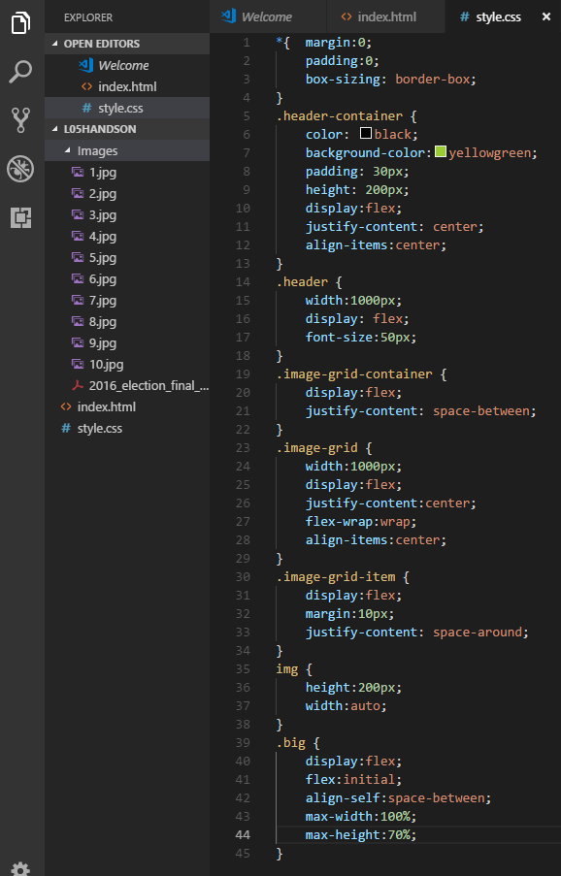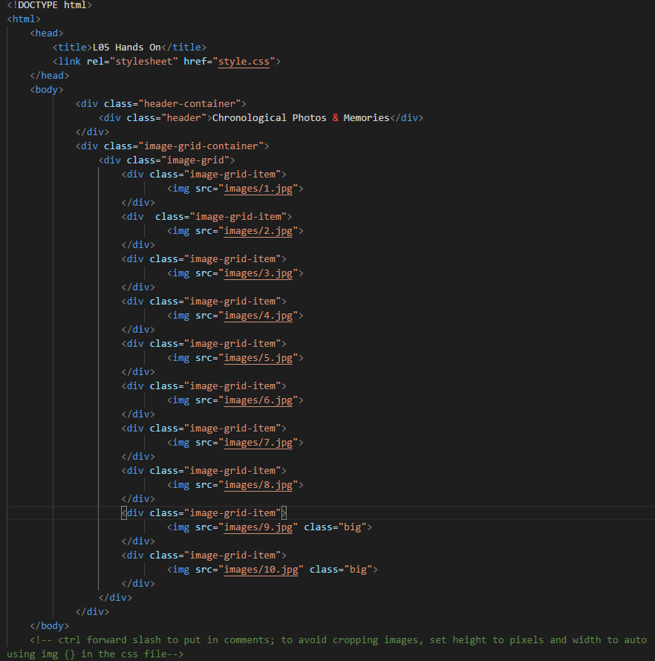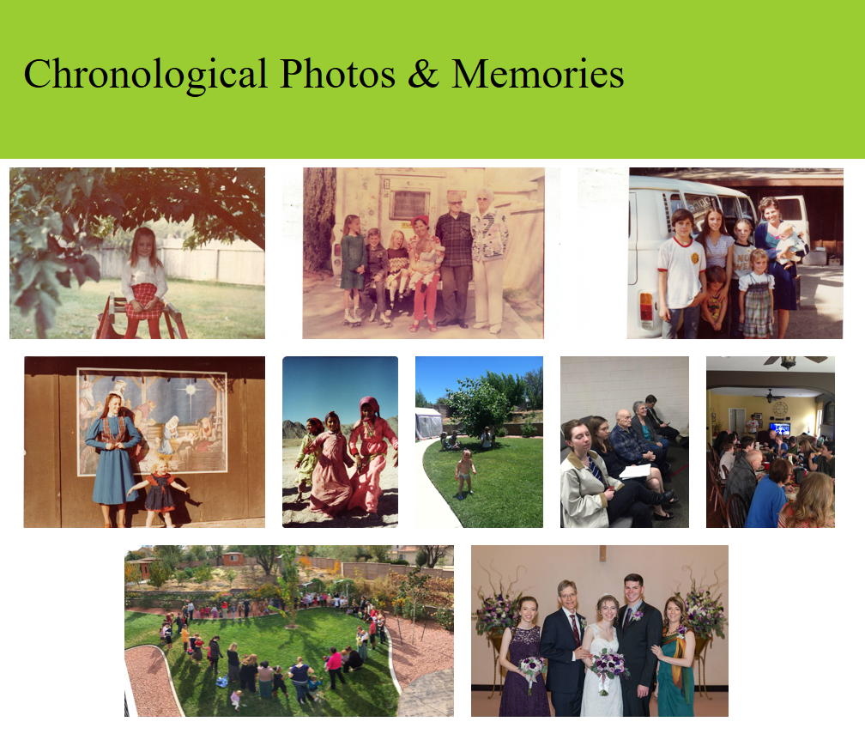

L06Bootstrap

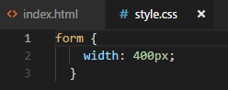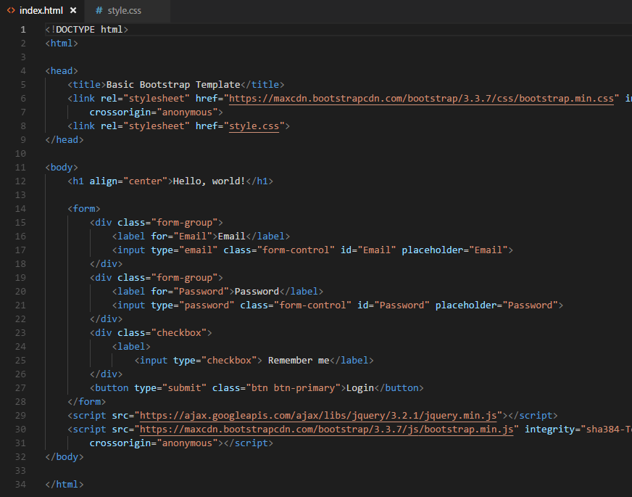

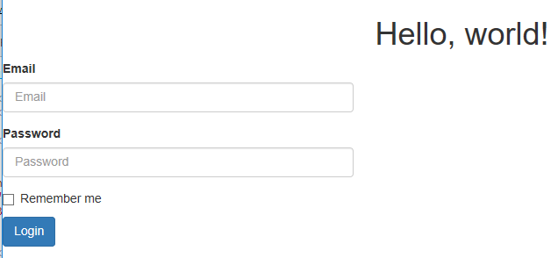

L06HandsOn

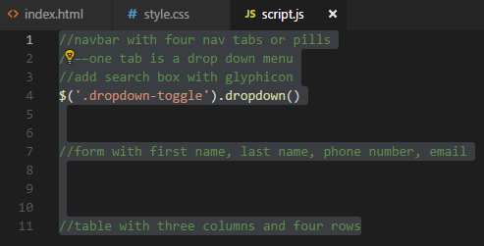

<!DOCTYPE html>

<html>

<head>

<title>Lesson Six Hands On</title>

<!-- Latest compiled and minified CSS -->

<script src="https://cdnjs.cloudflare.com/ajax/libs/popper.js/1.14.0/umd/popper.min.js"></script>

<link rel="stylesheet" href=

"https://maxcdn.bootstrapcdn.com/bootstrap/3.3.7/css/bootstrap.min.css"

integrity="sha384-BVYiiSIFeK1dGmJRAkycuHAHRg32OmUcww7on3RYdg4Va+PmSTsz/K68vbdEjh4u"

crossorigin="anonymous">

<link rel="stylesheet" href="style.css">

<script src="https://ajax.googleapis.com/ajax/libs/jquery/3.3.1/jquery.min.js"></script>

<script src="https://maxcdn.bootstrapcdn.com/bootstrap/3.3.7/js/bootstrap.min.js"></script>

</head>

<body>

<!-- navbar with four nav tabs or pills

one tab is a drop down menu

add search box with glyphicon -->

<div class=nav-container>

<div class="navbar">

<div class="glyphicon">

<a href="#" class="btn btn-info btn-lg">

<span class="glyphicon glyphicon-sunglasses"></span> Search

</a>

</div>

<div class="title">

<h2>Another Chance to Navigate</h2>

</div>

<div class="button-container">

<div class="dropdown">

<button class="btn btn-secondary dropdown-toggle" type="button" id="dropdownMenuButton" data-toggle="dropdown"

aria-haspopup="true" aria-expanded="false">Find Constellations

<span class="caret"></span>

</button>

<div class="dropdown-menu dropdown-menu-right" aria-labelledby="dropdownMenuButton">

<a target="_blank" class="dropdown-item" href="#">Orion</a>

<a class="dropdown-item" href="#">Scorpius</a>

<a class="dropdown-item" href="#">Vulpecula</a>

<a class="dropdown-item" href="#">Ursa Major</a>

</div>

</div>

<div class="nav-buttons">

<button class="btn btn-primary active" ><i class="icon-white icon-plus"></i>Back</button>

<button class="btn btn-primary active"><i class="icon-white icon-plus"></i> Forward</button>

</div>

</div>

</div>

</div>

<div class="below-nav">

<div form-container>

<form class="form-horizontal">

<div class="form-group">

<label for="Email" class="control-label col-xs-2">Email</label>

<div class="col-xs-10">

<input type="email" class="form-control" id="Email" placeholder="Email">

</div>

</div>

<div class="form-group">

<label for="Password" class="control-label col-xs-2">Password</label>

<div class="col-xs-10">

<input type="password" class="form-control" id="Password" placeholder="Password">

</div>

</div>

<div class="form-group">

<label for="firstname" class="control-label col-xs-2">First Name</label>

<div class="col-xs-10">

<input type="text" class="form-control" id="firstName" placeholder="First Name">

</div>

</div>

<div class="form-group">

<label for="lastname" class="control-label col-xs-2">Last Name</label>

<div class="col-xs-10">

<input type="text" class="form-control" id="lastName" placeholder="Last Name">

</div>

</div>

<div class="form-group">

<label for="phone" class="control-label col-xs-2">Phone Number</label>

<div class="col-xs-10">

<input type="text" class="form-control" id="phoneNumber" placeholder="Phone Number">

</div>

</div>

<div class="form-group">

<div class="col-xs-offset-2 col-xs-10">

<div class="checkbox">

<label>

<input type="checkbox"> Remember me</label>

</div>

</div>

</div>

<div class="form-group">

<div class="col-xs-offset-2 col-xs-10">

<button type="submit" class="btn btn-success">Login</button>

</div>

</div>

</form>

</div>

<div/>

</div>

<!-- table with three columns and four rows-->

<div class="table-container">

<table class="table table-bordered">

<thead>

<tr>

<th>Name</td>

<th>Question</td>

<th>Answer</td>

</tr>

</thead>

<tbody>

<tr>

<td>Orion</td>

<td>What is the cultural significance?</td>

<td>Hunter in Greek mythology</td>

</tr>

<tr>

<td>Scorpius</td>

<td></td>

<td></td>

</tr>

<tr>

<td>Ursa Major</td>

<td></td>

<td></td>

</tr>

<tr>

<td>Vulpecula</td>

<td></td>

<td></td>

</tr>

</tbody>

</table>

</div>

</div>

<script src="script.js"></script>

</body>

</html>

*{ margin: 0;

padding: 0;

box-sizing: border-box;

}

/*navbar with four nav tabs or pills*/

/*one tab is a drop down menu*/

/*add search box with glyphicon*/

.nav-container {

display:flex;

color:white;

background-color:lightblue;

border: solid;

height: 150px;

padding: 10px;

}

.navbar {

display:flex;

background-color:darkgreen;

width:1000px;

padding:10px;

align-content: space-between;

justify-content:space-between;

margin:auto;

}

.glyphicon {

display:flex;

align-self: flex-start;

}

.glyphicon-sunglasses {

display:flex;

align-self:stretch;

}

.btn-secondary {

background-color: yellow;

color:black;

}

.below-nav {

display:flex;

margin:auto;

justify-content:center;

}

/*form with first name, last name, phone number, email*/

form {

width: 500px;

float: left;

padding: 50px;

}

.form-container {

color: black;

background-color:rgb(194, 171, 41);

padding: 20px 0;

display:flex;

justify-content: center;

}

.form-group {

color: blue;

background-color:yellow;

}

/*table with three columns and four rows*/

.table-container {

color: white;

padding: 50px 0;

display:flex;

justify-content: space-around;

float:left;

margin-left: 30px;

}

.table {

width:400px;

padding: 20px;

background-color:green;

}

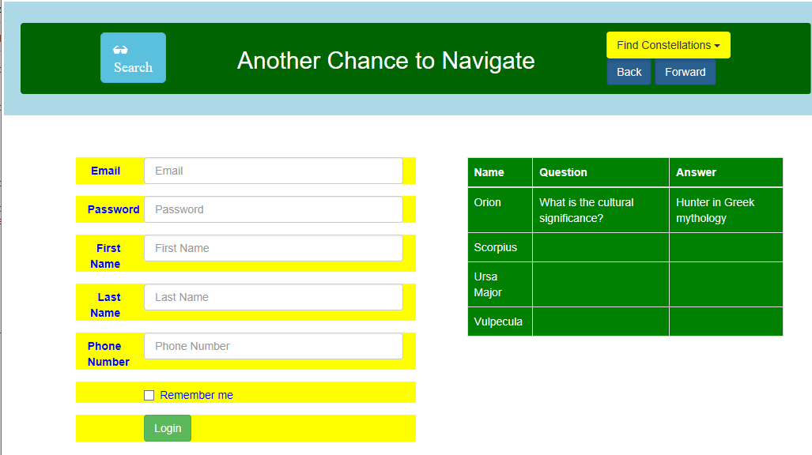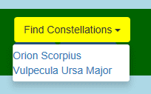

L07HandsOn

<!DOCTYPE html>

<html>

<head>

<title>Lesson 7 DOM</title>

<link rel="stylesheet" href="style.css">

</head>

<body>

<div class="nav-container">

<div class="navbar">

<h1>

Please Enter Your First & Last Name

</h1>

<h2>Capitals required. Use multiple letters. No numbers</h2>

</div>

</div>

<div class="form-container">

<form class="form">

First name:<br>

<input id="first" type="text" name="firstname" placeholder="FIRST">

<br>

Last name:<br>

<input id="last" type="text" name="lastname" placeholder="LAST">

<br><br>

<button id=btn type="button" onclick="fullName()">Submit</button>

</form>

</div>

<p id="output">Full name here. </p>

<script src="script.js"></script>

</body>

</html>

.nav-container {

display: flex;

justify-content: center;

}

.navbar {

background-color: rgb(89, 211, 219);

color:black;

padding:20px;

width: fit-content;

}

.form-container {

display: flex;

justify-content: center;

margin:10px;

padding: 30px;

}

.form {

background-color:rgb(89, 211, 219);

color:black;

width: fit-content;

padding: 10px;

}

function fullName (){

let lastName=document.getElementById("last").value;

let firstName=document.getElementById("first").value;

let nameRegex=('^[A-Z{2,}]');

if (firstName.match(nameRegex) && lastName.match(nameRegex)) {

let fullName=firstName+" "+lastName;

document.getElementById("output").innerHTML=fullName;

alert ("Thank you.");

} else {

alert ("Please capitalize the first letter of your first name." +

"Names must be longer than one character." + "No numbers allowed.");

}

}

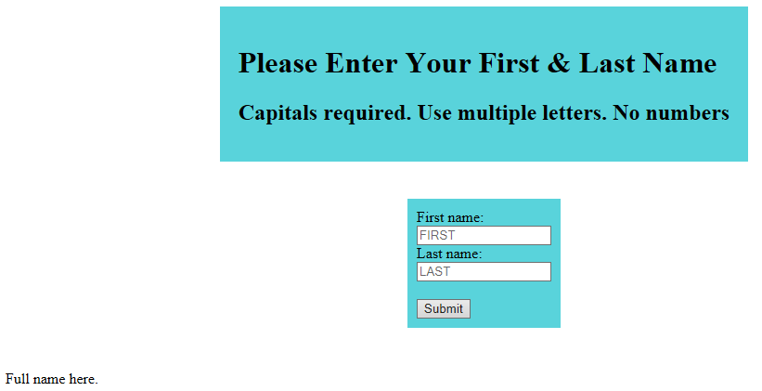

Flexbox

<!DOCTYPE html>

<html>

<head>

<title>Flex Box Lesson</title>

<link rel="stylesheet" type="text/css" href="style.css">

</head>

<body>

<div class="menu-container">

<div class="menu">

<div class="date">Date </div>

<div class="links">

<div class="sign up">Sign Up</div>

<div class="login">Log In</div>

</div>

</div>

</div>

<div class="header-container">

<div class="header">

<div class="subscribe">Subscribe &#9662</div>

<div class="logo">

<img src="images/logo.png"/>

</div>

<div class="icons">

<img src="images/icons.svg"/>

</div>

</div>

</div>

</div>

<div class="image-grid-container">

<div class="image-grid">

<div class="image-grid-item first-item">

<img src="images/one.png"/>

</div>

<div class="image-grid-item">

<img src="images/two.png"/>

</div>

<div class="image-grid-item">

<img src="images/three.png"/>

</div>

<div class="image-grid-item">

<img src="images/four.png"/>

</div>

<div class="image-grid-item">

<img src="images/five.png"/>

</div>

</div>

</div>

<script src="script.js"></script>

</body>

</html>

*{

margin:0;

padding:0;

box-sizing: border-box;

}

.menu-container {

color: white;

background-color: blue;

padding: 20px 0;

display: flex;

justify-content: center;

}

.menu {

width: 900px;

display: flex;

justify-content: space-between;

}

.links {

display:flex;

justify-content: flex-end;

}

.login {

display: flex;

margin-left: 20px;

}

.header-container {

color: black;

background-color: lightblue;

display: flex;

justify-content: center;

}

.header {

width:900px;

height:300px;

display:flex;

justify-content:space-between;

align-items: center;

}

.image-grid-container {

display:flex;

justify-content: center;

}

.image-grid {

width:900px;

display:flex;

justify-content: center;

align-items: center;

flex-wrap: wrap;

flex-direction: row;

}

.image-grid-item {

width: 235px;

height: 250px;

}

.first-item {

order: 1;

}

.last-item {

order: -1;

}

.icons,

.subscribe {

align-self: flex-end;

margin-bottom: 20px;

}

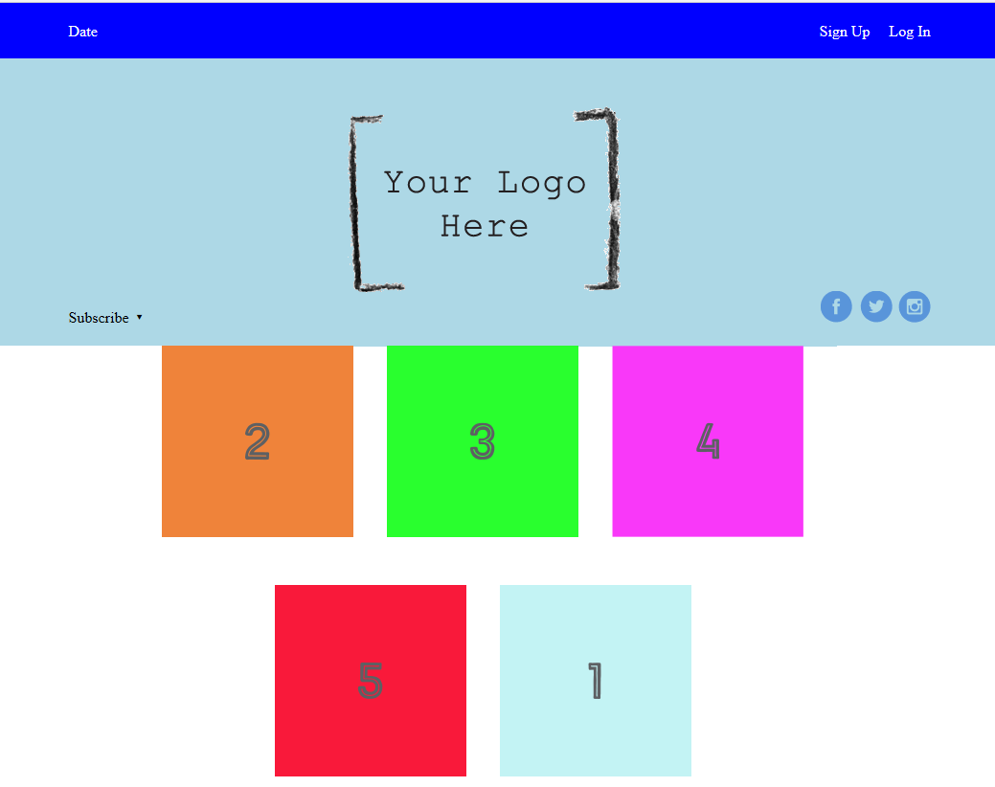

jQuery Starter

<!DOCTYPE html>

<html>

<head>

<meta charset="utf-8">

<title></title>

<link rel="stylesheet" type="text/css" href="style.css">

<script src="https://code.jquery.com/jquery-3.2.1.min.js" integrity="sha256-hwg4gsxgFZhOsEEamdOYGBf13FyQuiTwlAQgxVSNgt4=" crossorigin="anonymous"></script>

</head>

<body>

<header>ADOPT A PET</header>

<div class="entry"></div>

<br><br>

<div class="panel">

<h1>Let's Adopt a Pet!</h1>

<p class="p1">Our organization is dedicated to finding beautiful, loving and homeless pets and matching them with amazing owners! If you are looking to adopt, check out our pets below! If you find one you absolutely adore, please contact us with your information. Meow!</p>

<button>Hide all pets</button>

</div>

<div class="pets">

<p class="pets">Sherri</p>

<img src="images/cat.jpeg">

</div>

<div class="pets">

<p class="pets">Arthur</p>

<img src="images/dog.jpg">

</div>

<div class="pets">

<p class="pets">Coco</p>

<img src="images/bird.jpeg">

</div>

<div class="pets">

<p class="pets">Midnight</p>

<img src="images/black-cat.jpg">

</div>

<div class="pets">

<p class="pets">Frenchy</p>

<img src="images/french-bulldog.jpeg">

</div>

<div class="pets">

<p class="pets">Simon & Garfunkel</p>

<img src="images/guinea-pigs.jpeg">

</div>

<div class="pets">

<p class="pets">Ralph</p>

<img src="images/ralph.jpg">

</div>

<div class="pets">

<p class="pets">Rupert</p>

<img src="images/puppy.jpeg">

</div>

<div class="panel" id="contact">

<h1>Want a Pet? Contact us!</h1>

<p id="rainbows">Name: <input class="name"><br>

Phone: <input class="phone"> <br>

Email: <input class="email"> <br>

Pet: <input class="pet"></p> <br>

<!-- Consider this HTML and following JS -->

<!-- <h3>Describe yourself: </h3> <textarea type="text"></textarea>

<p>Keypresses: <div>0</div></p> -->

</div>

<script src="jquery.js"></script>

</body>

</html>

/*Students Add Code Here*/

.blue {

background-color: blue;

font-size: xx-large;

}

/*Styling for the website*/

body{

background-color: #262326;

background-image: url("images/manypugs.jpg");

background-size: contain;

}

button {

margin-left: 47%;

}

.entry {

background-image: url("images/kittens-cat-cat-puppy-rush-45170.jpeg");

background-size: cover;

height: 700px;

width: 100%;

}

header {

background-color: transparent;

color: #262326;

text-align: center;

font-size: 50px;

font-family: Georgia;

font-weight:900;

text-shadow: 2px 2px #c2736b;

}

h1{

text-align: center;

font-family: Georgia;

color: #c2736b;

}

p{

text-align: center;

font-family: Georgia;

}

.p1{

padding-left: 100px;

padding-right: 100px;

padding-bottom: 20px;

}

.panel {

background-color: #262326;

/* margin-right: 70px;

margin-left: 70px;*/

margin-bottom: 8%;

padding: 10px;

/*width: 100%;*/

color:#F1EFE9;

}

.pets {

background-color: #c2736b;

margin-right: 20%;

margin-left: 20%;

margin-bottom: 5%;

padding-bottom: 5%;

padding-top: 2%;

font-size: 40px;

color:#262326;

}

img {

/*padding-top: 20px;*/

/*border-radius: 8%;*/

display: block;

margin: auto;

}

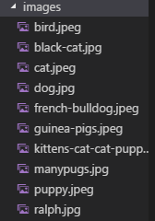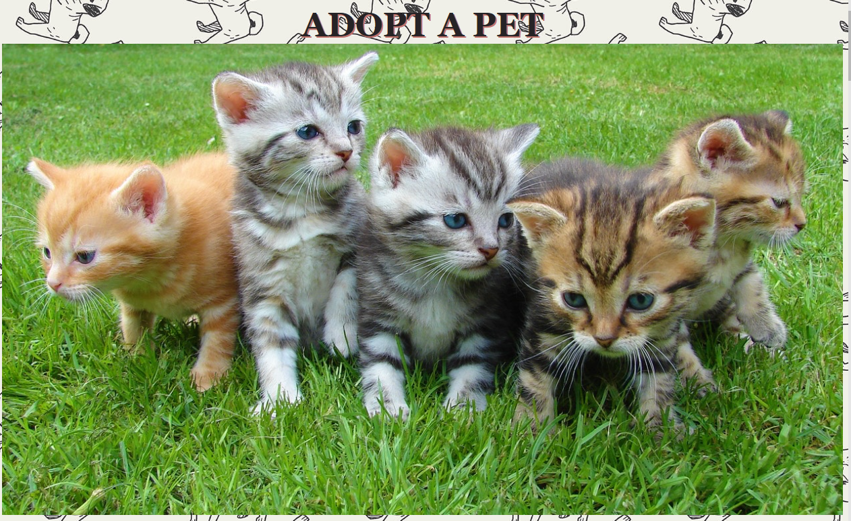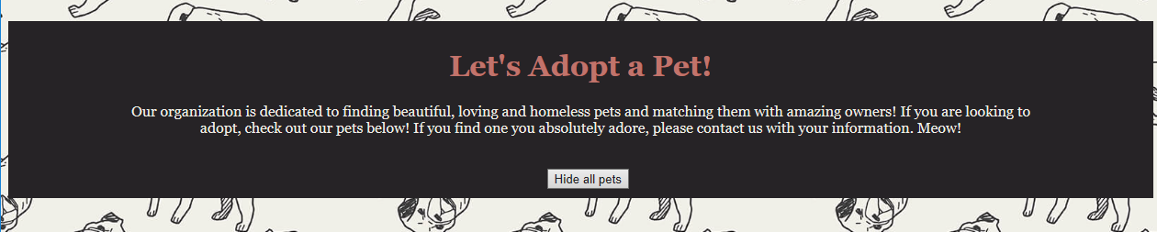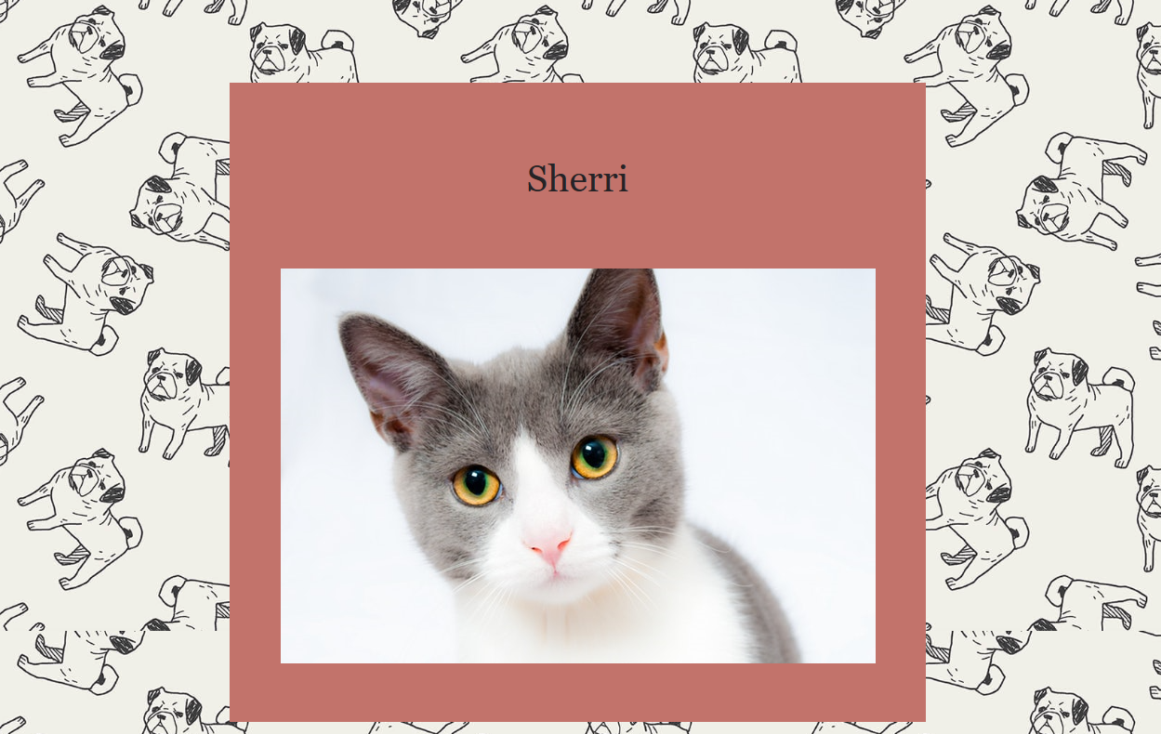

L08HandsOn

<!DOCTYPE html>

<html>

<head>

<title></title>

<link rel="stylesheet" href="style.css"></link>

<script src="https://code.jquery.com/jquery-3.2.1.min.js"

integrity="sha256-hwg4gsxgFZhOsEEamdOYGBf13FyQuiTwlAQgxVSNgt4="

crossorigin="anonymous"></script>

<script src="https://ajax.googleapis.com/ajax/libs/jquery/3.3.1/jquery.min.js"></script>

</head>

<body>

<div class="header-background">

<header ><h1>jQuery Intro: Lesson 8</h1></header>

</div>

<div class="main-container">

<div class="p-container">

<p>"Click here to learn more about jQuery!"</p>

</div>

<div class="list-container">

<ul "list-group">

<li class="list-group-item">JavaScript&#160&#160&#160&#160&#160&#160</li>

<li class="list-group-item">C#&#160&#160&#160&#160&#160&#160</li>

<li class="list-group-item">Java&#160&#160&#160&#160&#160&#160</li>

<li class="list-group-item">Ruby&#160&#160&#160&#160&#160&#160</li>

<li class="list-group-item">Python</li>

</ul>

</div>

<div class="input-container">

First Name: <input type="text" id="firstName" placeholder="First Name Here" class="box">

Last Name: <input type="text" id="lastName" placeholder="Last Name Here" class="box">

</div>

<img src="Ship.jpg" alt="Ship"/>

</div>

<script src="script.js"></script>

</body>

</html>

// Use jQueryto change the font color of the header when the mouse hovers;

// when the mouse stops hovering, return to the original color.

$(document).ready(function(){

$("p").hover(function(){

$(this).css("color", "red");

}, function(){

$(this).css("color", "black");

});

});

$(document).ready(function(){

$("p").click(function(){

$("p").text("jQuery is a fast, JavaScript library that makes " +

"many tasks easier and simpler to accomplish. A JavaScript " +

"library contains pre-written JavaScript which makes developing " +

"applications a bit easier for the developer. This means jQuery " +

"is not a language, but an extension of JavaScript. It takes many " +

"lines of JavaScript code, which we would have had to write ourselves " +

"before jQuery, and compresses it.");

});

});

$(document).ready(function(){

$(".list-group-item").dblclick(function(){

$(this).hide();

});

});

$(document).ready(function(){

$("input").keydown(function(){

$("input").css("color", "red");

});

});

*{

margin:0;

padding:0;

}

.header-background {

display:flex;

justify-content: center;

color:black;

background-color:grey;

border: solid;

border-color:black;

border-width: 10px;

padding: 20px;

font-size:4vw;

}

.main-container {

display:flex;

flex-direction: column;

background-color: lightgrey;

border: solid;

margin:10px;

padding: 10px;

font-size:3vw;

}

.p-container {

display:flex;

background-color:white;

justify-content: center;

margin:10px;

padding: 10 px;

border:solid;

}

.list-container {

display:flex;

flex-wrap:wrap;

background-color:white;

justify-content: center;

margin:10px;

padding: 10 px;

border:solid;

}

ul {

display:flex;

list-style-type:none;

}

.input-container {

display:flex;

background-color:white;

justify-content: space-between;

padding: 10 px;

margin:10px;

border:solid;

}

input {

font-size:3vw;

}

.box {

width: 50%;

border:none;

}

.input {

color:red;

}

img {

padding:20px;

}

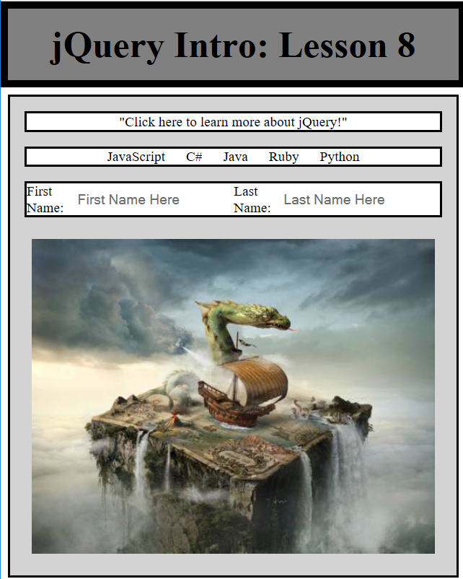

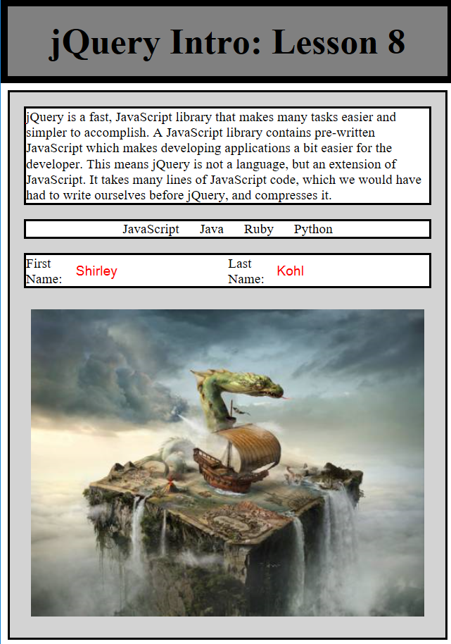

L09HandsOn

